**Bilateral shoulder pain**

**Initial Assessment**

|  |  |  |
| --- | --- | --- |
| **Presenting Symptom/Chief Complaint** | | |
| Patient is persecuting with bilateral shoulder pain, sleep disturbances due to pain that interfering with daily living and work. | | |
| **Main Signs and Symptoms** | | |
| Pain at the neck and both shoulders area that getting worse with the physical activity and rainy cold weather. | | |
| **Other Signs and Symptoms** | | |
| Otherwise the patient is healthy. | | |
| **TCM Diagnosis and Treatment (identified TCM disease, TCM differentiation of syndromes)** | | |
| Chronic obstruction, painful syndrome at the upper back and shoulders area due to invasion of cold and dampness Qi and blood stagnation. | | |
| **Treatment Principles and Strategies** | | |
| Remove dampness. Expel cold. Stimulate blood and Qi movement at the area, nourish Qi and blood. | | |
| **Treatment Plan (Modalities; acupuncture, herbal, dietary, manual therapies), frequency and duration** | | |
| Acupuncture 2-3 times a week with distal points, sedation for 10-15 min following by local point’s tonification with Moxibition and warming needles. | | |
| **Any other Advice Given to Patients** | | |
| Acupuncture: Du20, Du14, Gb 20, GB 21, SI9, SI10, SI11, SI14, TW15. **Extra** 9 points at the front of the shoulder. Distal points with strong sedation method following by tonification for 45-50 min. ST38 (LR), LI4 (LR), LI11 (LR), St36 (LR), SI3 with sedation at the acute phase. St43; St44 (bilaterally) with involved neck and occipital headache. UB60, UB40, UB62, P6, SP6, St36 tonification with warmed needling. | | |
| **Practitioner:** | **Date:** | **Signature:** |

**Bilateral shoulder pain**

**Daily Charting____________________________________Patient Name:_**

**Date:**

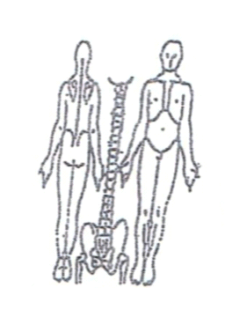 **Working Diagnosis**: Chronic painful obstruction syndrome with

acute exacerbation of cold and dampness invasion. Qi and blood stagnation at the area (repetitive injury due to work)

S: Patient is complaining of a sharp pain at the upper back and both shoulders area; muscle spasm due to stress at the repetitive work.

O:

Treatment (P) Acupuncture: Du20, Du14, Gb 20, GB 21, SI9, SI10, SI11, SI14, TW15. Extra 9 points at the front of the shoulder. Distal points with strong sedation method following by tonification for 45-50 min. ST38 (LR), LI4 (LR), LI11 (LR), St36 (LR), SI3 with sedation at the acute phase. St43; St44 (bilaterally) with involved neck and occipital headache. UB60, UB40, UB62, P6, SP6, St36 tonification with warmed needling.

(A) Acupuncture 1 hour according to plan.

**Date:**

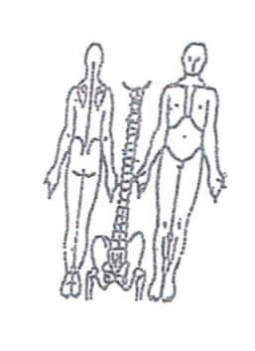**Working Diagnosis:**

S: Pain still aggravated having pain, entire upper back spasm muscle. Pain is getting worse with work and daily activities at the end of the day.

O:

Treatment (P) Acupuncture and Moxibition. Sedation protocol with local points

tonification for 1 hour.

(A)

**Date:**

**Working Diagnosis:**

S: Patient is more relax, pain and spasm at the upper back. ROM. Still having pain

at the end of the day

O:

Treatment (P) Acupuncture with tonification and warm needling for 1 hour.

(A)

**Date:**

**Working Diagnosis:**

S: Patient sleep N; N ROM. Pain still coming up at the end of the day but less intensive.

N level of energy.

O:

Treatment (P) Acupuncture + Moxa – 1 hour according to the treatment plan.

(A)

**Date:**

**Working Diagnosis:**

S: Patient sleep N; N ROM. Pain still coming up at the end of the day but less intensive.

N level of energy.

O:

Treatment (P) Acupuncture + Moxa – 1 hour according to the treatment plan.

(A)

**Date:_**

**Working Diagnosis:**



S: Patient sleeping N, No pain at the upper back and shoulders area. N ROM.

O:

Treatment (P) Acupuncture with Moxibition with moving (rotation) of the shoulders. Start shoulders’ exercises.

(A)